LAB 04
Introduction to

Microsoft Access 2016

A database is a collection of information that is related. Access allows you to manage your information in one database file. Within Access there are four major objects: Tables, Queries, Forms and Reports.

Tables store your data in your database

Queries ask questions about information stored in your tables Forms allow you to view data stored in your tables

Reports allow you to print data based on queries/tables that you have created

The Navigation Pane

The Navigation Pane is a list containing every object in your database. For easier viewing, the objects are organized into groups by type. You can open, rename, and delete objects using the Navigation Pane.

To Minimize and Maximize the Navigation Pane:

Click the double arrow in the upper-right corner of the Navigation Pane to minimize and maximize.
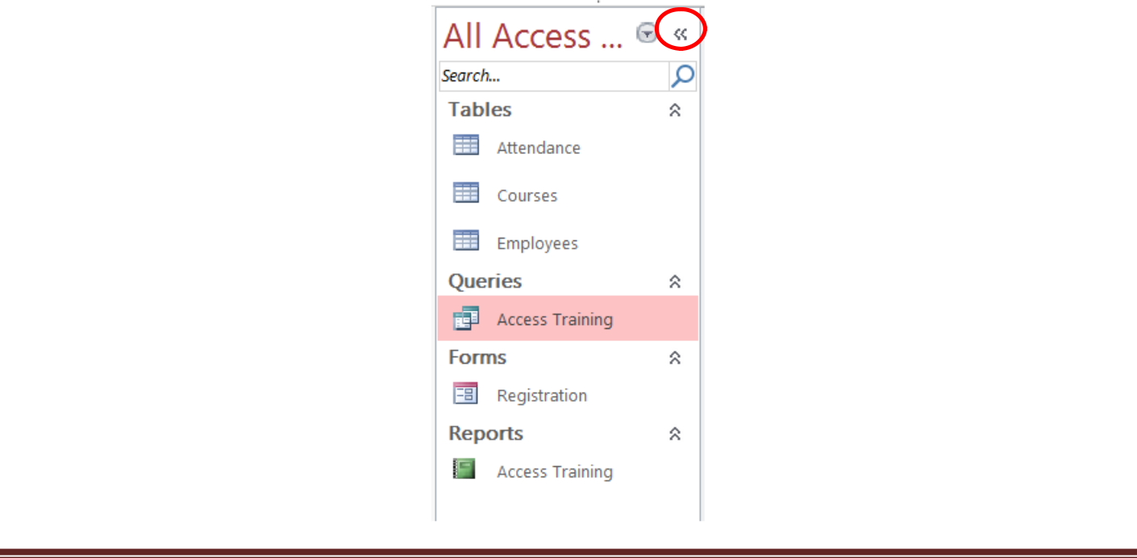

3-17 1
Sorting the Objects in the Navigation Pane:
By default, objects are sorted by type, with the tables in one group, the forms in another, etc.
However, you can change how the objects are sorted.

Click the drop-down arrow to the right of the All Access Objects and click on a sort option from the list.
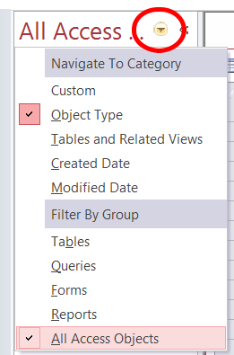

Creating a Database

- Start Access
- Click on Blank desktop database
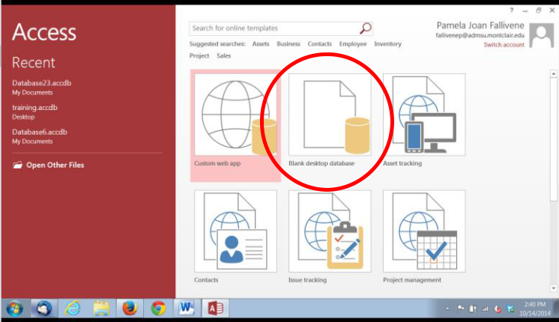

- Under File Name type a name for the database

- To change the location of where to store the database, click the folder icon and select a location
- Click Create
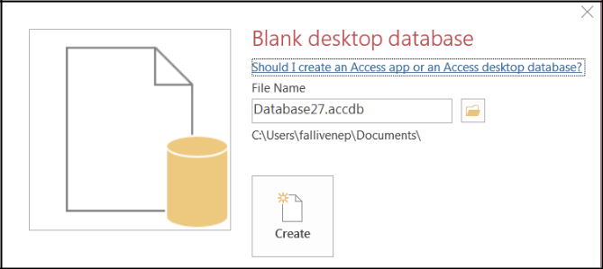

2
Access opens in a new table in Datasheet View.

Understanding Views

There are multiple ways to view a database object. The two views for tables are Design View and Datasheet View.

Design View is used to set the data types, insert or delete fields, and set the Primary Key Datasheet View is used to enter and view the data for the records

Switching Between Design View and Datasheet View:
Click the View arrow on the Home tab and click on either Datasheet View or Design View
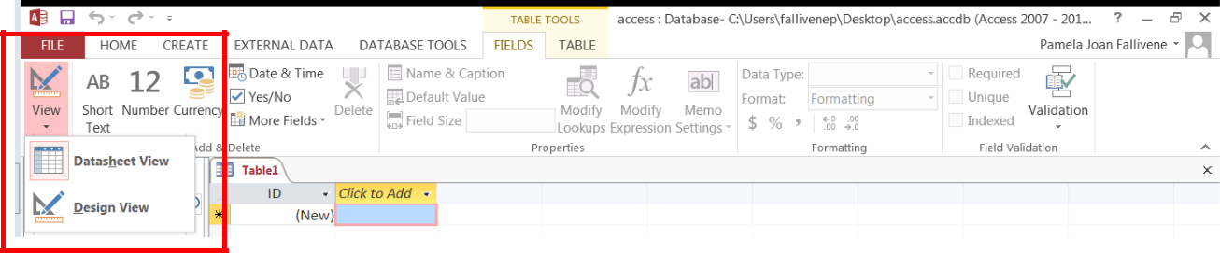

Creating a Table

A table is a collection of data about a specific topic, such as employee information, products or customers. The first step in creating a table is entering the fields and data types. This can be done in either Datasheet View or Design View but it is recommended to set up the table in Design View.

Understanding Fields and Their Data Types
Field - an element of a table that contains a specific item of information, such as a last name.
Field’s Data Type - determines what kind of data the field can store.

Format | Use to display
Short Text | Alphanumeric data (names, titles, etc.) - up to 255 characters
Long Text | Large amounts of alphanumeric data: sentences and paragraphs – 64,000 characters
Number | Numeric data
Date/Time | Dates and times
Currency | Monetary values
AutoNumber | Unique value generated by Access for each new record
Yes/No | Yes and No values and fields that contain only one of two values
OLE Object | Pictures, graphs, or other ActiveX objects from another Windows-based application
Hyperlink | A link address to a document or file on the Internet
Attachment | You can attach files such as pictures, documents, spreadsheets, or charts; each
 | Attachment field can contain an unlimited number of attachments per record, up to the
 | storage limit of the size of a database file.
Calculated | You can create an expression that uses data from one or more fields. You can
 | designate different result data types from the expression.
Lookup Wizard | Displays either a list of values that is retrieved from a table or query, or a set of values
 | that you specified when you created the field. The Lookup Wizard starts and you can
 | create a Lookup field. The data type of a Lookup field is either text or number,
 | depending on the choices that you make in the wizard.
 | 3

To Create a Table in Design View:
- Click on the Create tab
- Click on Table
- Switch over to Design View on the Home tab
- If prompted to save the table, enter a name and click on OK
- Type the field names and select the appropriate data type for each field
- Continue until all fields are added

Note: The order that you enter the field names is the order the fields will appear in the table.
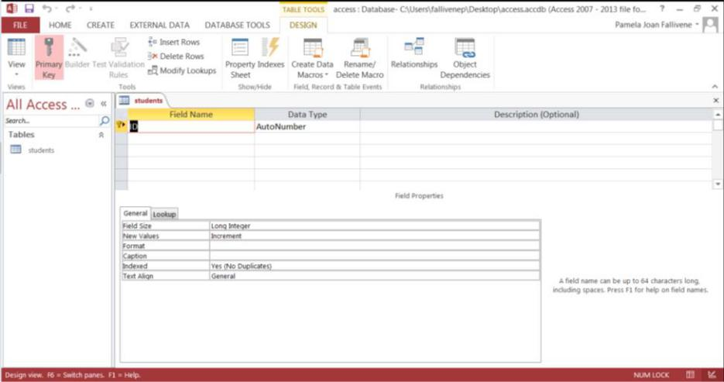

Setting a Primary Key

The Primary Key is the unique identifier for each record in a table. Access will not allow duplicate entries in a primary key field. When creating a new table, Access automatically creates a field “ID” with the autonumber data type, and assigns this as the Primary Key.

To Set a Primary Key:
- In Design View, position your cursor in the field you wish to set as the Primary Key
- Click the Primary Key button on the toolbar
- Save the table

Note: To turn off the Primary Key simply click on the Primary Key button again.
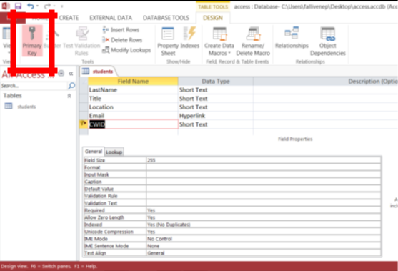

4
Input Masks

An input mask is used to pre-format a field to “look/act” a certain way when a user inputs data.

Examples: Social Security Number input mask automatically inserts the dashes; phone numbers automatically inserts the parentheses and dashes.

The input mask data can either be stored in the table or simply displayed and not stored.

To Create an Input Mask for a Field:
- In Design View, click in a field for which you’d like to apply an input mask

- In the Field Properties section at the bottom of the screen, click in the Input Mask line and notice the Build button that appears at the right end of the line (see below):
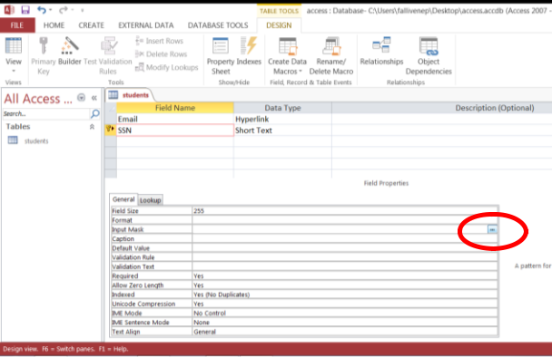

3. Click the Build button to start the Input Mask Wizard (shown below).
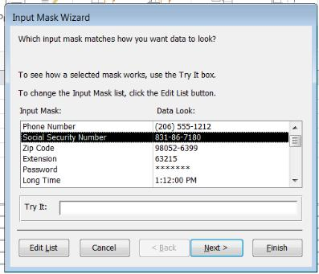

- Select the appropriate input mask
- Click Next
- Click Next for additional screens on which you can set options for the input mask
- Click Finish on the last screen of the input mask wizard

To Save the Table:
- Click the Save icon on the toolbar
- Enter a name for the table if you haven’t done so already
- Click OK

5
Entering Data in a Table

- In Datasheet View, start typing the data into the table by pressing the tab key to move to the next cell

- When you have completed the record (row), press Enter
- You can also click on the New record icon on the Home tab in the Records group
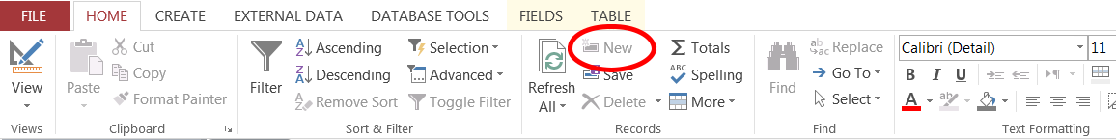

Navigating in a Table

Use the arrows at the bottom of the table to navigate among records.

Sorting Records in a Table

- Position your cursor in the field that you wish to sort by clicking on any record in the table

- Click either the Sort Ascending or Sort Descending icon on the Home tab in the Sort & Filter group
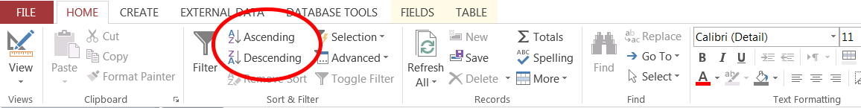

Queries

You use queries to view, change, and analyze data in different ways. You can also use them as a source of records for forms and reports.

To Create a Query:
- Click on the Create tab
- Click on Query Design in the Queries group
- Select the table that you would like to base your query on
- Click Add
- Repeat steps 3 and 4 until all tables are added
- Close the Show Table window

6
The table(s) will now be displayed in the upper part of the Query Design Screen by boxes containing the tables’ fields.

- Double-click on the field names in the field list window which you would like to include in the query
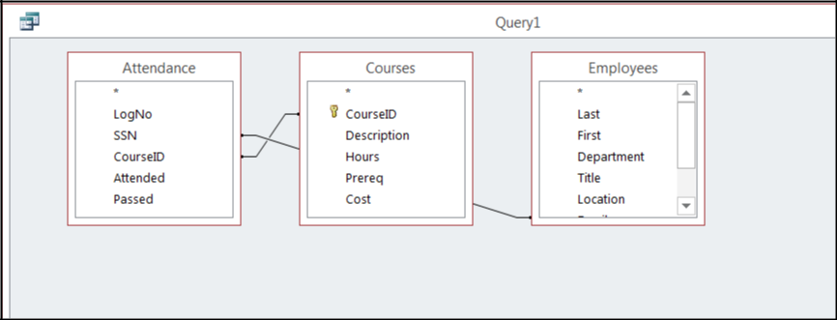

Defining Criteria in the Query

In order to control which records are displayed, you must define criteria in a query. The most common type of query is the Select Records query which will be discussed below.

To Define Criteria for Your Query:
- Position your cursor in the criteria row in the field for which you wish to define the criteria for
- Type the criteria

Example: To find all Excel courses:

- Position your cursor in the criteria row of the Course ID field

- Type Excel (Access adds the quote marks to the criteria automatically when you tab to the next column)
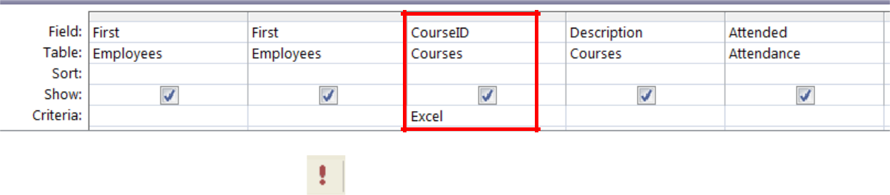

5. Click the Run Query button

To Save the Query:
- Click the Save icon
- Enter a name for the query
- Click OK

7
Creating a Form

A form is a database object that is used to enter or display data in a database.

To Create a Form:
- Open the table or query on which you are basing the form
- Click on the Create tab
- Click on Form in the Forms group

A form is created and opens in Layout View.
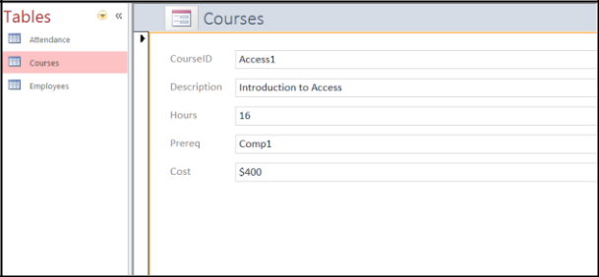

Different Views:
Form View – this view allows you to view, create and edit records

Layout View - this view is similar to Design View but is more visually-oriented in that each control displays real data. As a result, this is a very useful view for setting the size of controls, or performing many other tasks that affect the visual appearance and usability of the form. Design View - this view gives you a more detailed view of the structure of the form. You can see the header, detail, and footer sections for the form. You cannot see the underlying data while you are making design changes.

Reports

Reports can be based on tables or queries.

To Create a Report:
- Open the table or query on which you are basing the report
- Click on the Create tab
- Click on Report in the Reports group

A report is created in Layout View.
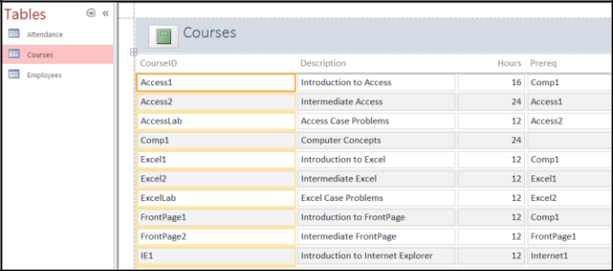

8
Different Views:

Print Preview – allows you see what the report would look like on a printed piece of paper Report View – allows you to see the data without having to display it in Print Preview Layout View – allows you make design changes while browsing your data Design View - gives you a more detailed view of the structure of your report

Printing Reports

To Print a Report:
- Switch to Print Preview from View on the Design tab under Report Layout Tools
- Click the Print icon
- Click on OK
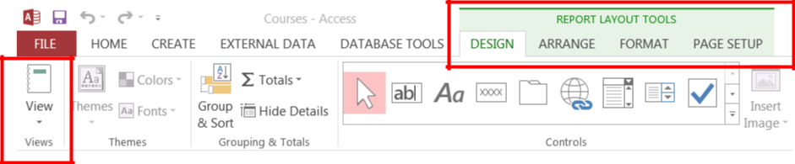

LAB ACTIVITY
Create a database file, which will require you to create one table, one query, one form, and one report.

Create table: CUSTOMERS

Create the field names and their properties as you need them to store your specific data for customers. You will have at least five customers with their information included in your customer table.

CUSTOMERS Table Field Names:

Customer ID (Primary Key: CID)
First Name (FNAME)

Last Name (LNAME)
City (CITY)

State (STATE)

Number of Purchases (PNUMBER)
Total Amount of Purchases (PTOTAL)

Date of Last of Purchase (PLAST)

Create query for Customers

Create a query that displays only the customers having Customer ID less than 6 sorted by last name in ascending order.

Create report: Customers Report

Create a report from the NY Customers query.

Create form: New Customers

Create a form for the Customers table. Include all fields in the form. Use the Form Wizard to create a form. Using the New Customers form, enter two additional customers:

Marion Morrison New Paltz NY 3 $150.00 March 12, 2010 Adam Jones Kingston RI 2 $250.00 March 17, 2010

9

